Shell Smash

Research

Collision

If the mass of the two circles are the same and there speed is the same ,the momentum will have the same magnitude but in the opposite direction right before the two circles collide with one another.

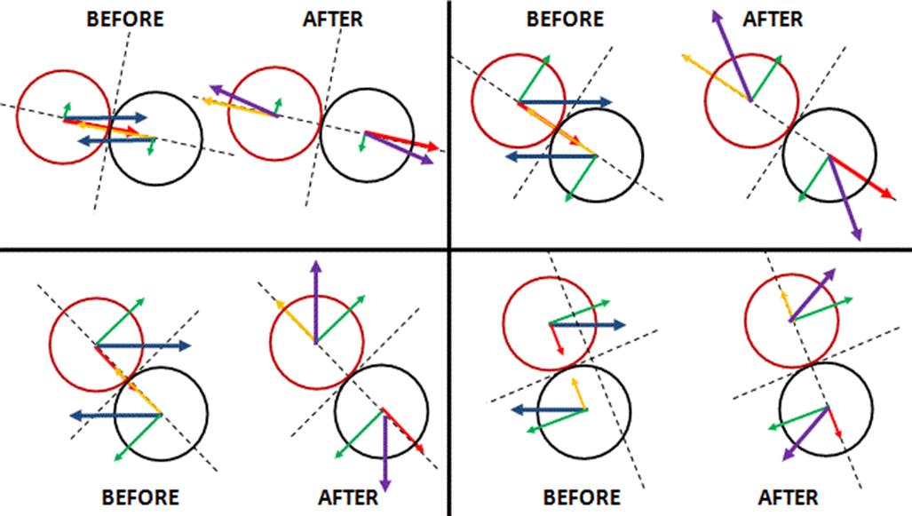

Processing collisions

To understand what has happened when two circle have collided ,you have to find the contact point and find the plane of collision . In the fourth diagram you have the tangent line which help identify the point of contact between both circles.

Shell data

Score

Movement

Launching

Friction

Collision

Detection

Processing a collsion

Bouncing of walls

drawing